Speculative risk:



Nero bauto recently opened:

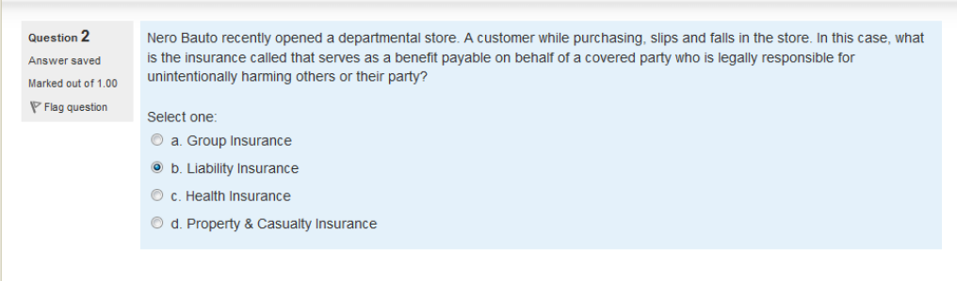

Captive insurance:

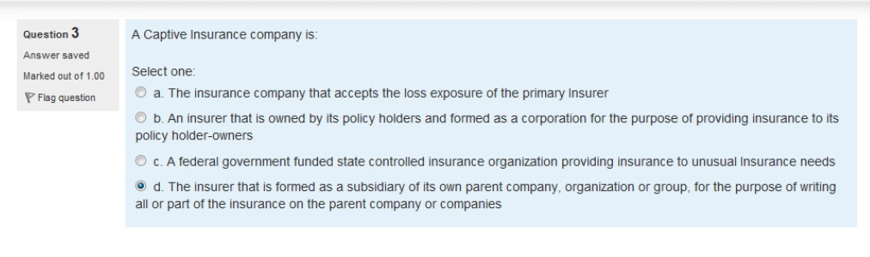

Reinsurance:

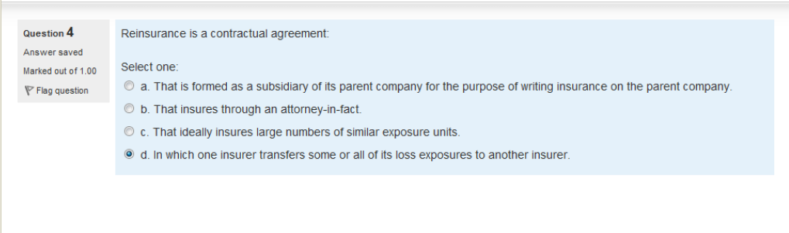

On Dec 3 2012



Justin Mark is planning

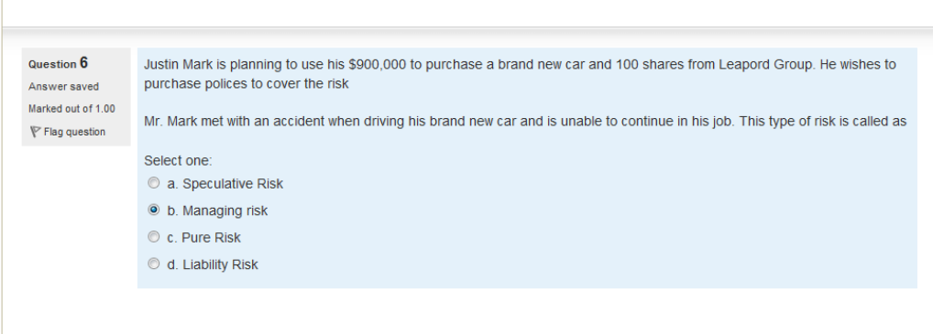

Basic form coverage



What is hazard



The following statements are about variable life(vl)

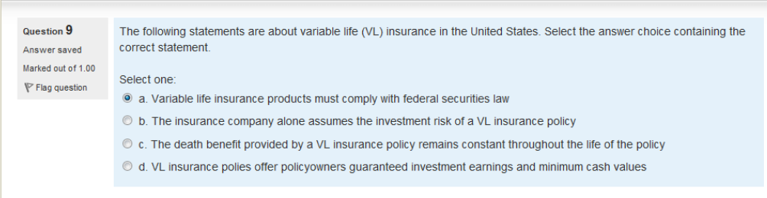

Which of the following is not considered to be an ideaaly insurable loss exposure

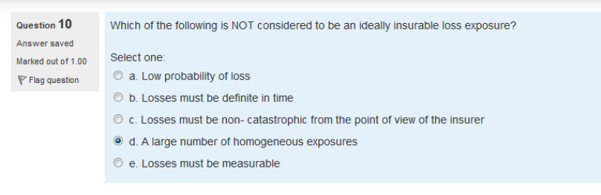

An employer purchases a fidelity bond

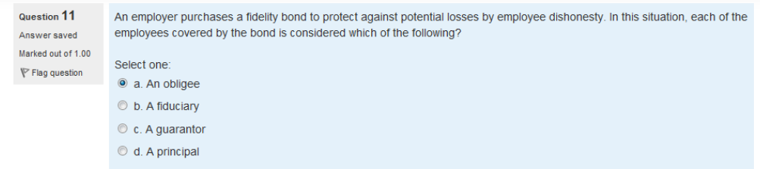

Ms.Jenifer struss purchased

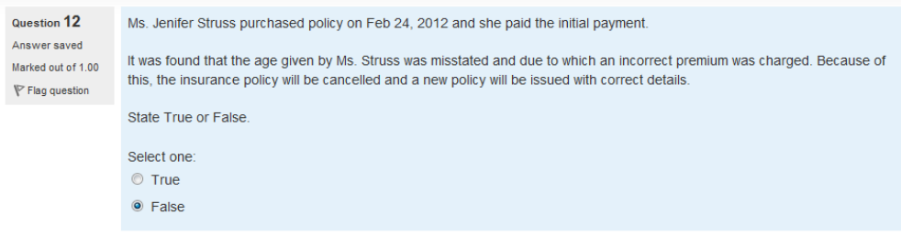

owners policies

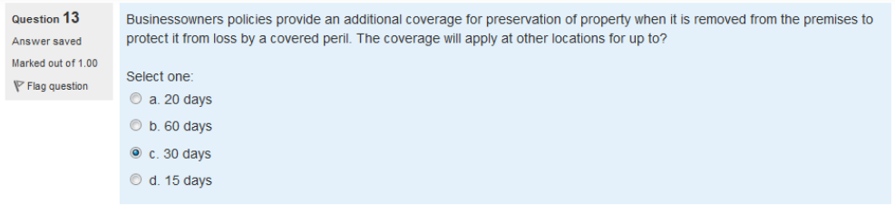

Alphs insurance company

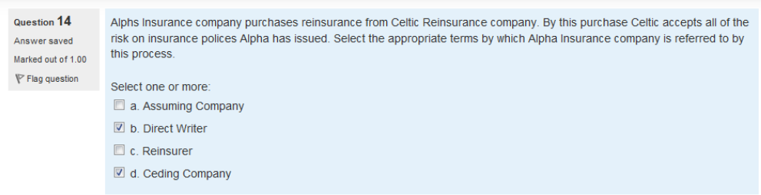

The paragraph below



Mr.Albert James purchased

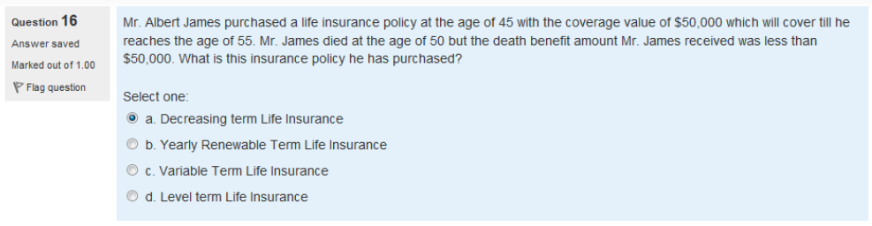

Risk management tool

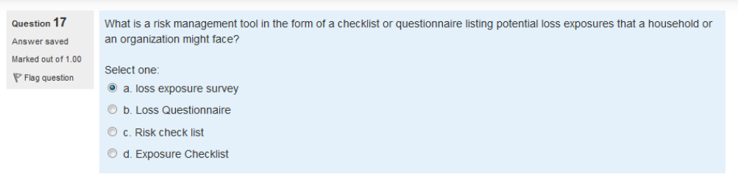

irda

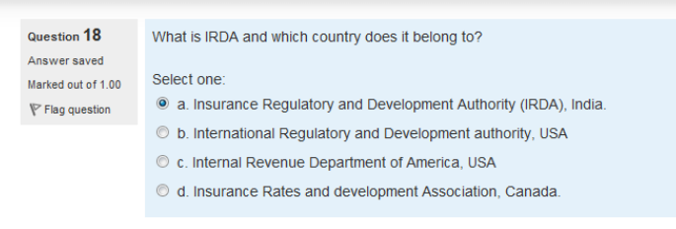

reduction in value of property

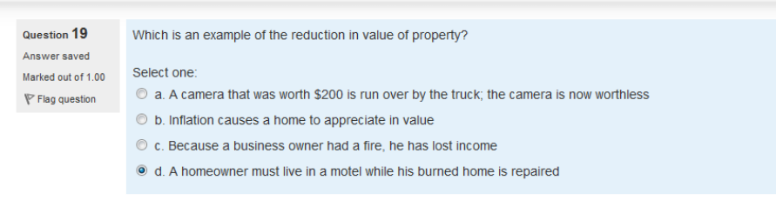

Ocean marine

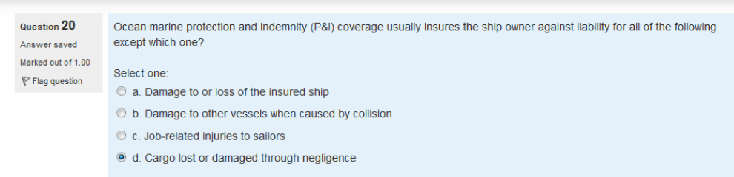

Individuals and business often

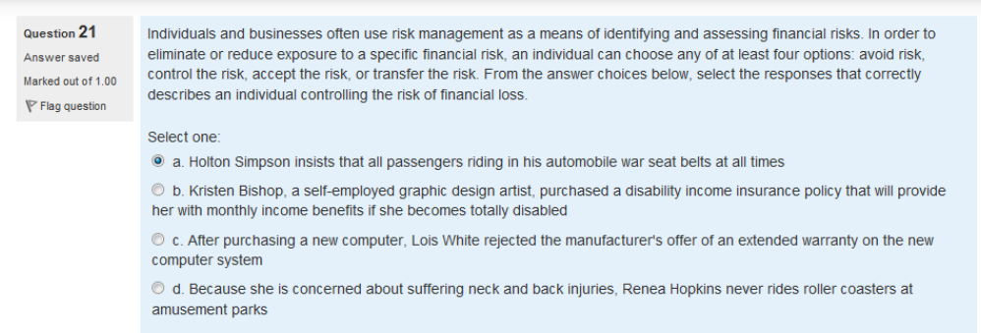

The falcon mutula life insurance company

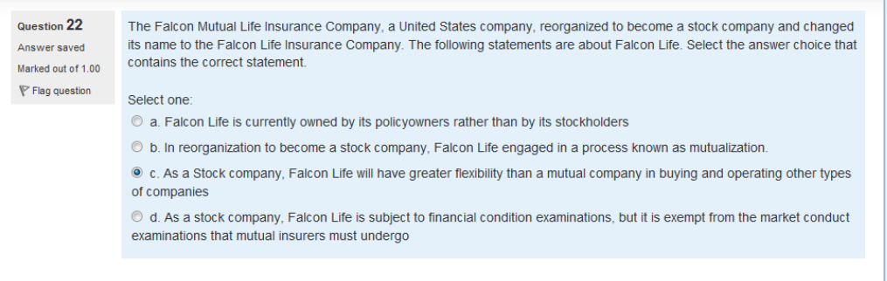

Justin mark

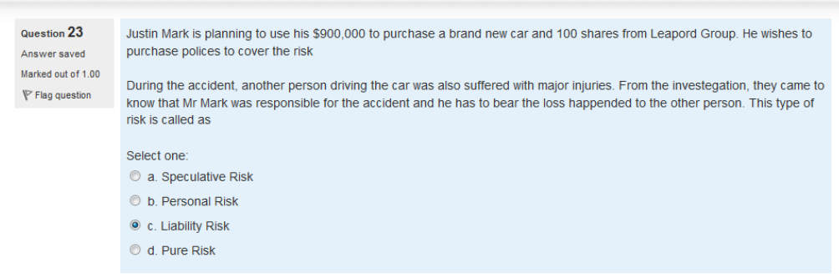

Federal government program



All of the following

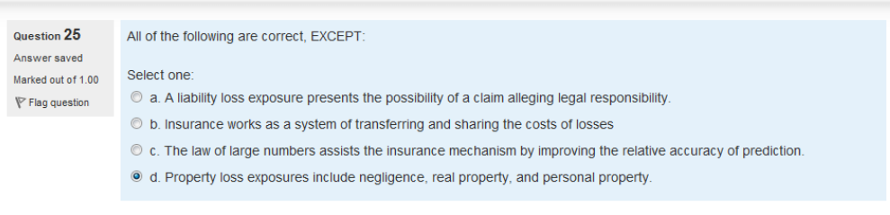

Prudential individual life

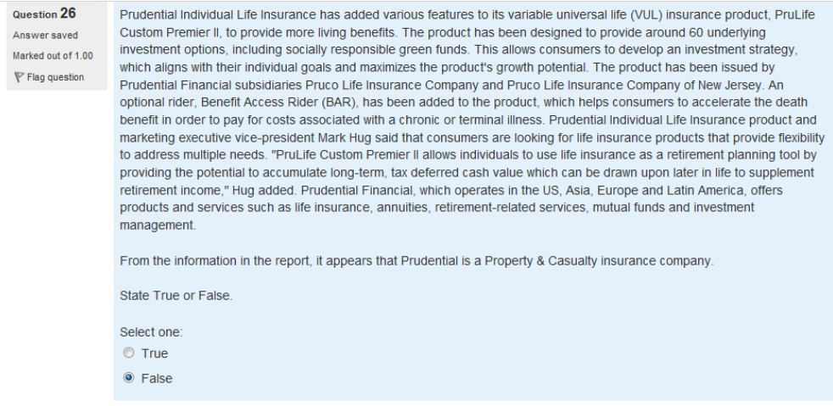

Utmost good faith

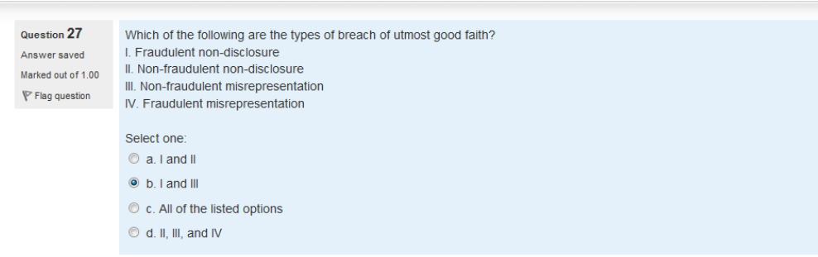

Restoring

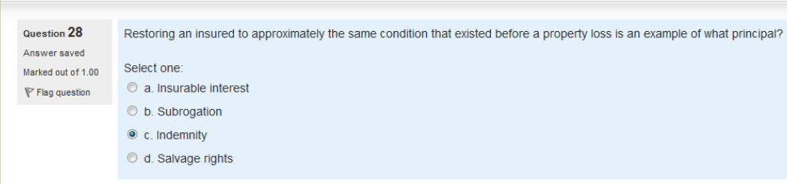

Risk management process



Henry martin

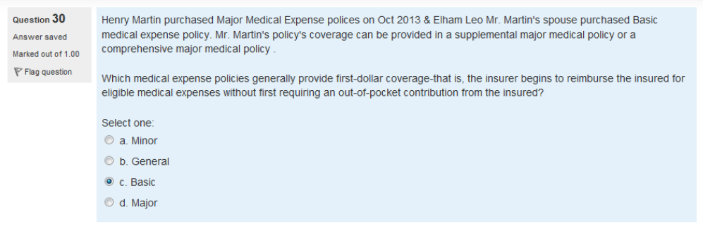

With holding,

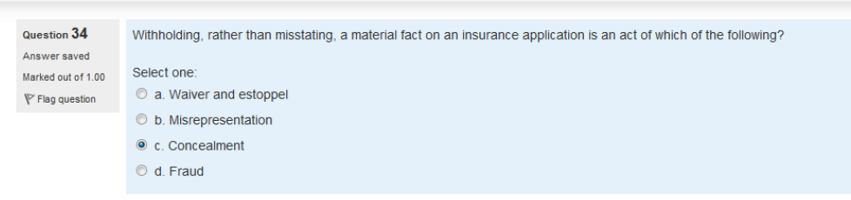

Time element coverage



Common law defenses

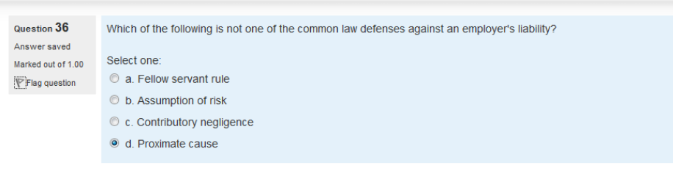

bailment



Contracts between(wrong)

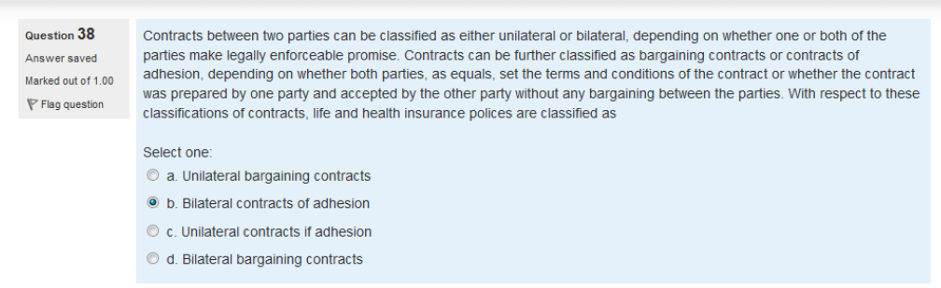

Insurance interest



Russell osteen

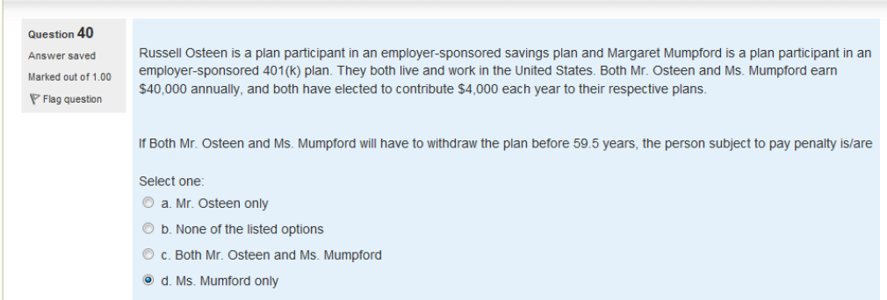

.

The use of standard forms



Grain insurance company

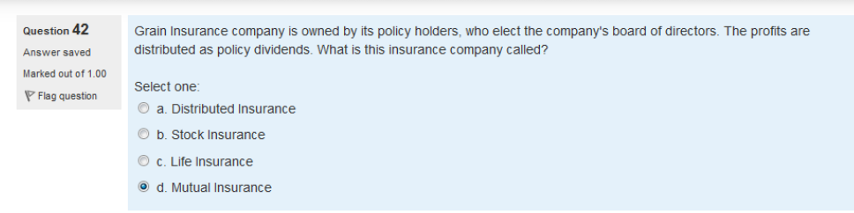

hazop



Managed care

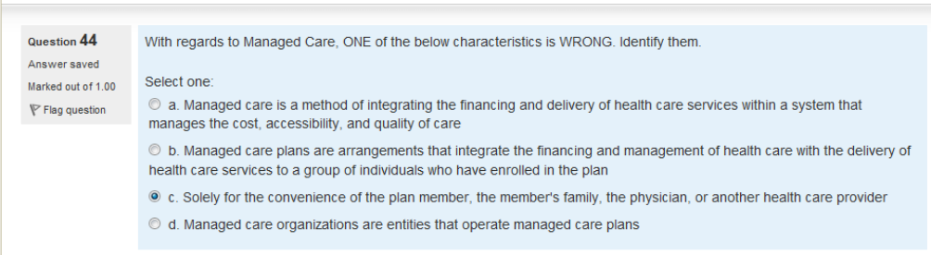

Mr.james black

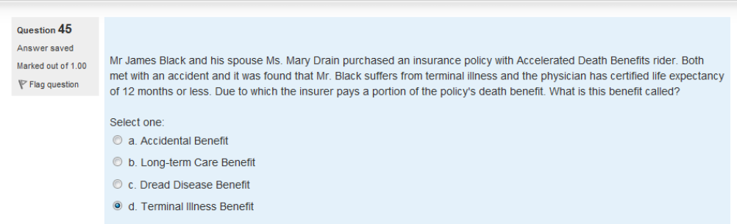

Brown company’s

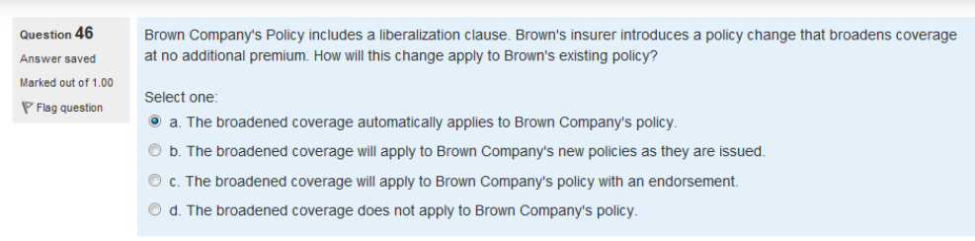

When pricing insurance

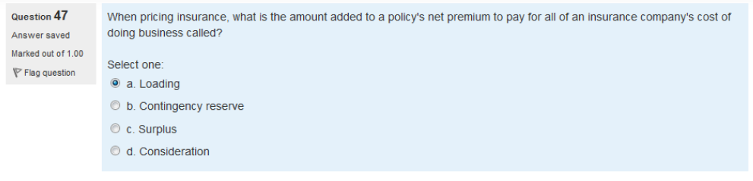

Prudential individual life

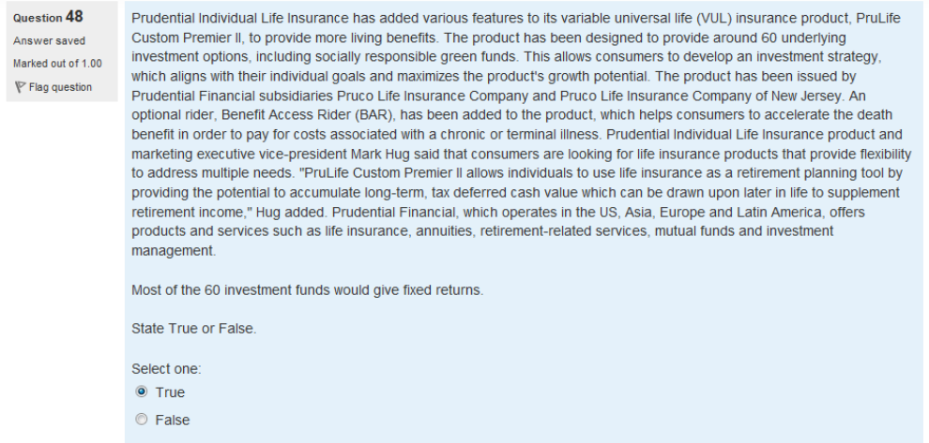

except

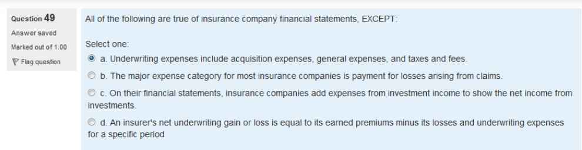

Two major

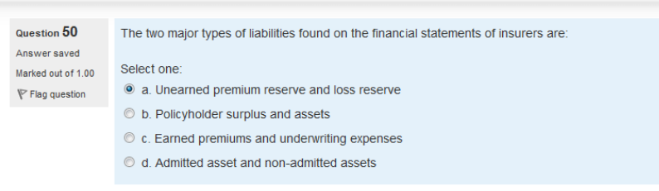

Loss control



On dec 3 2012



Risk management process



Insurance companies



insurers

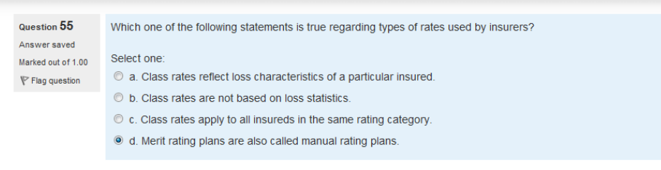

B choubey

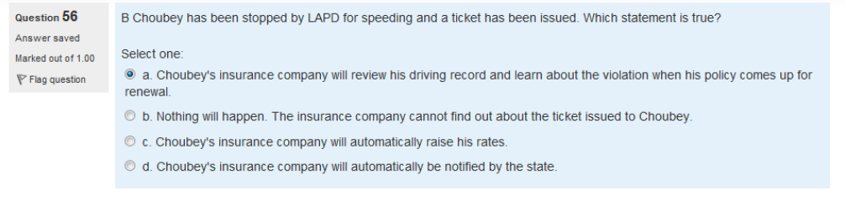

Sr-22

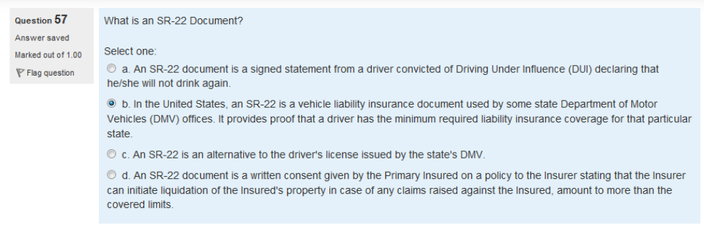

Insurance terminology



match



Most liability insurance